Chapter 15, Solution 7.

(a) 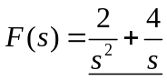

(b) 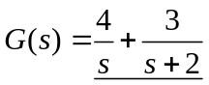

(c ) 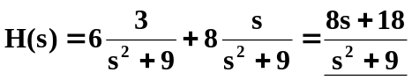

(d) From Problem 15.1,
